Bonus Features Documentation

Bonus Overview
The Smart Lost & Found project includes additional advanced AWS capabilities beyond the mandatory project requirements. These bonus features improve monitoring, automation, and system security.
The implemented bonus features are:
- Advanced monitoring with Amazon CloudWatch.
- Scheduled automation using Amazon EventBridge.
- Advanced data security using Cognito, API Gateway JWT Authorizer, IAM, and private S3 access.

1. Advanced Monitoring with Amazon CloudWatch
Amazon CloudWatch is used to monitor the serverless backend of the Smart Lost & Found system. Since the project relies on multiple AWS Lambda functions, CloudWatch provides logs and monitoring data that help track function execution, debug backend errors, and observe system behavior.

CloudWatch Usage in the Project
CloudWatch is used to monitor the following Lambda functions:
- createLostItem
- getLostItems
- claimItem
- updateItemStatus
- sendDailySummary
- deleteItem
Each Lambda function writes execution logs to Amazon CloudWatch Logs. These logs help verify that API requests are reaching the backend correctly and help identify errors during item creation, image processing, claim submission, status updates, and scheduled summary execution.

CloudWatch Alarm
A CloudWatch Alarm was configured to monitor Lambda errors. If the number of errors reaches the defined threshold, the alarm can trigger a notification through Amazon SNS.
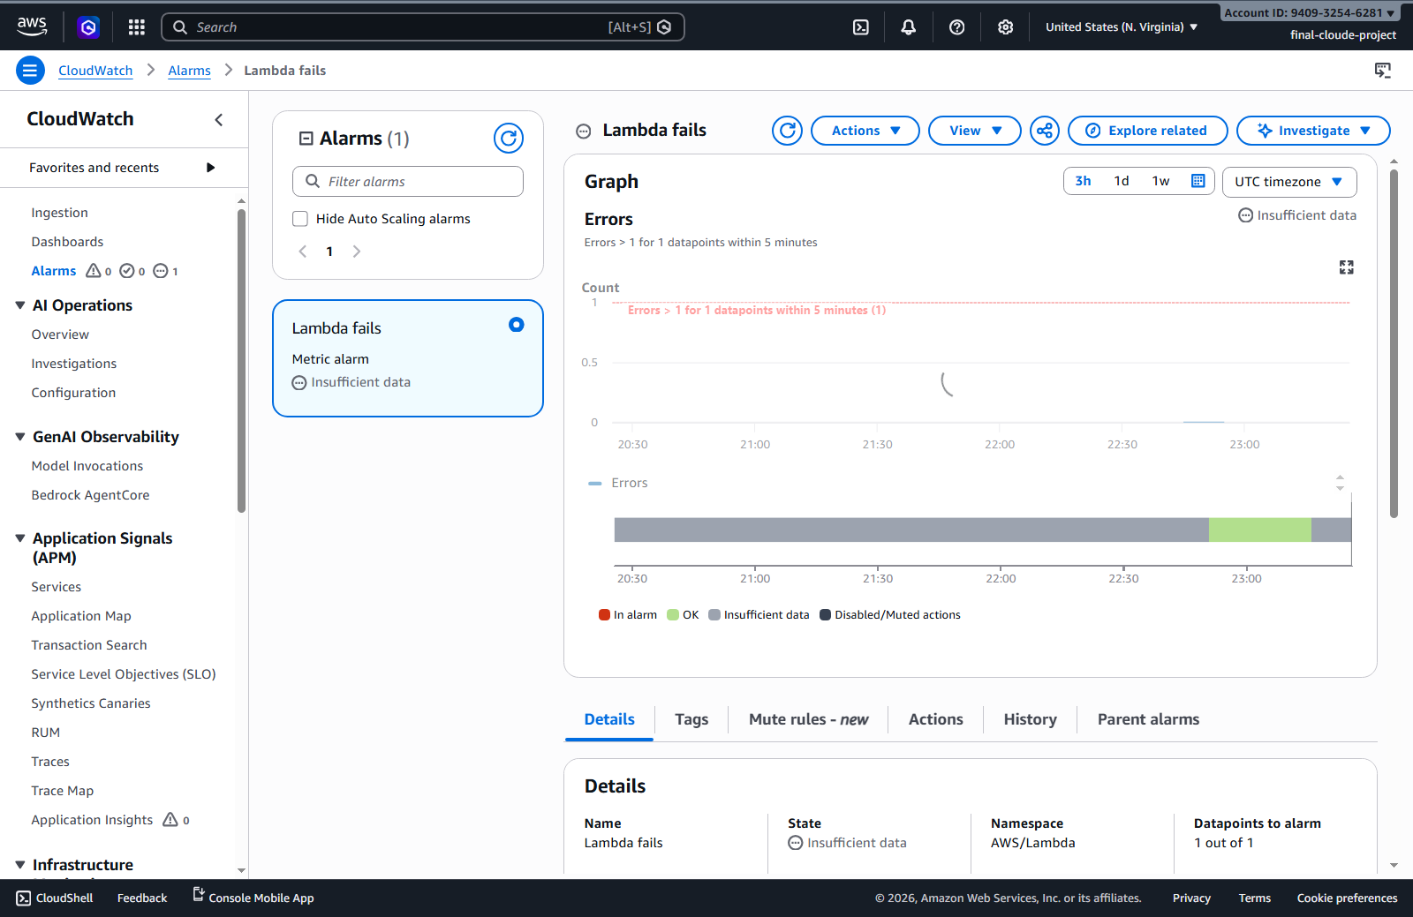
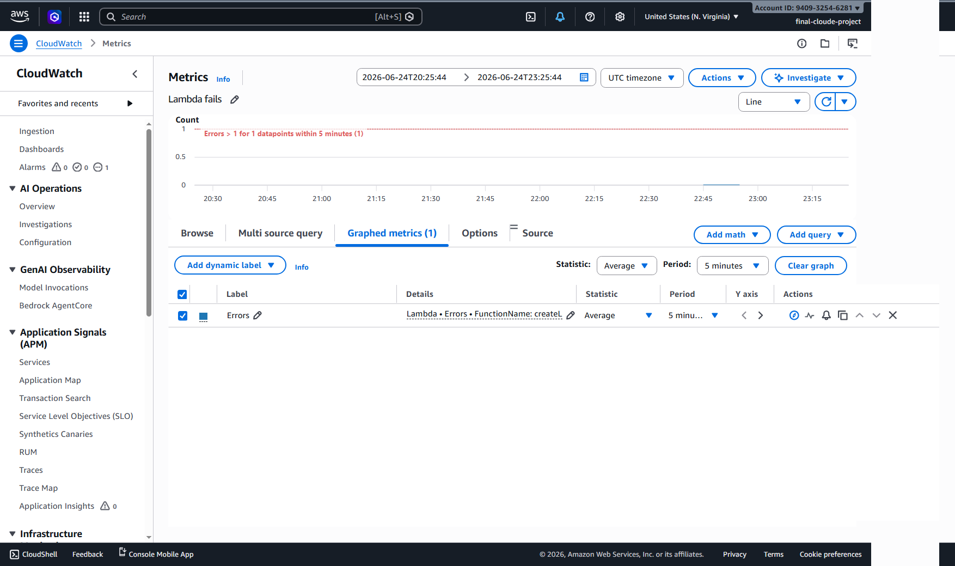

2. Scheduled Automation Using Amazon EventBridge
Amazon EventBridge is used to automate a scheduled backend task. The project includes an EventBridge rule that triggers the sendDailySummary Lambda function automatically.

EventBridge Workflow
Amazon EventBridge Rule
↓
sendDailySummary Lambda
↓
DynamoDB LostFoundItems Table
↓
Amazon SNS Notification
The scheduled Lambda function reads item data from the DynamoDB table and prepares a summary of the current lost and found system status.

Daily Summary Content
The summary can include:
- Total number of reported items.
- Number of lost items.
- Number of found items.
- Number of claimed items.
- Number of returned items.
The summary is then sent through Amazon SNS as an automated notification.

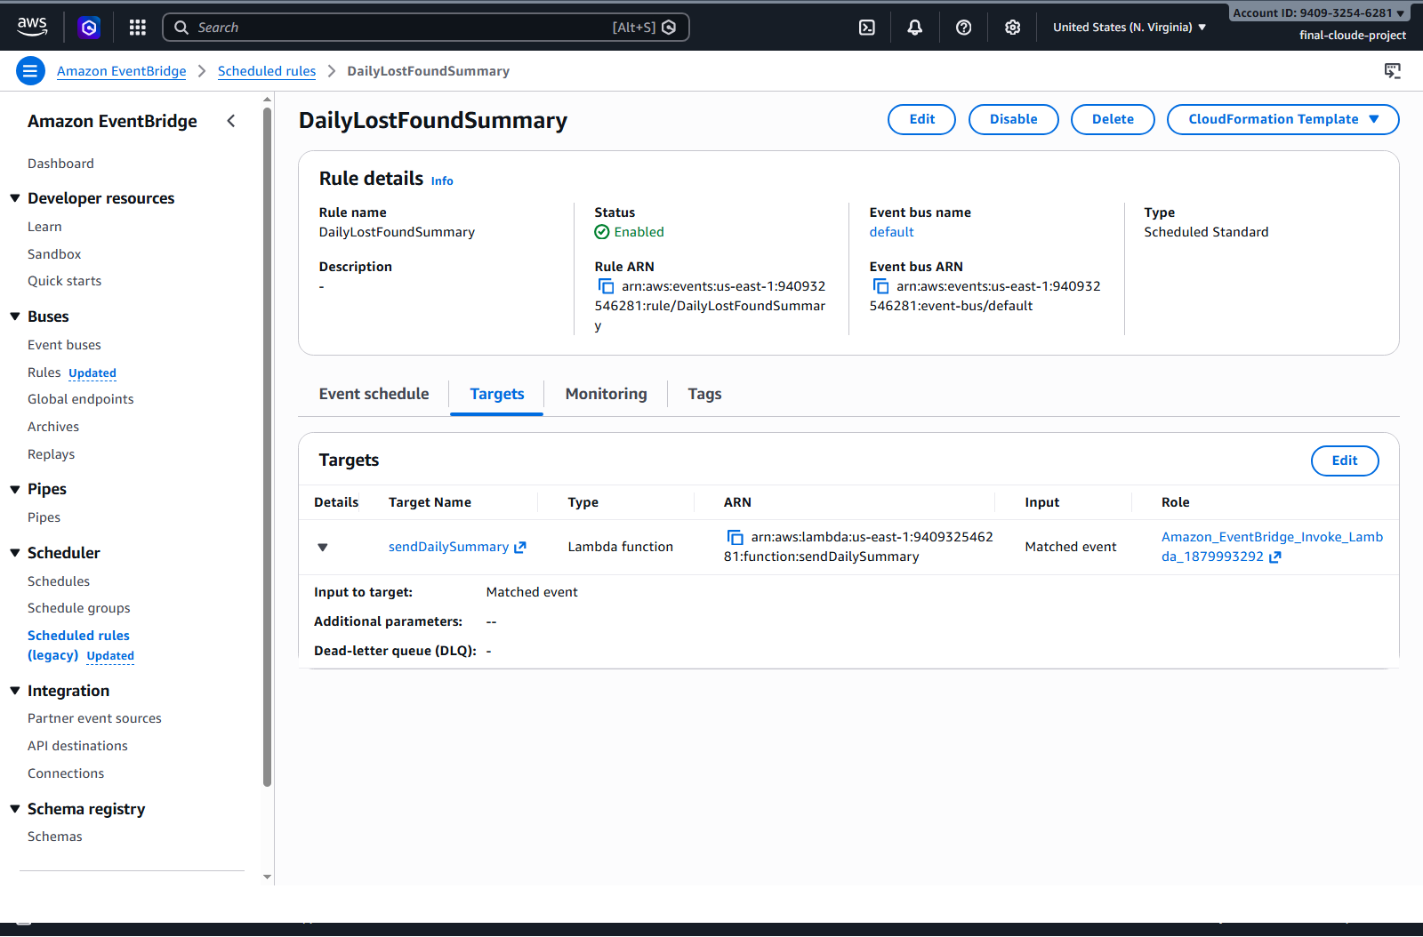
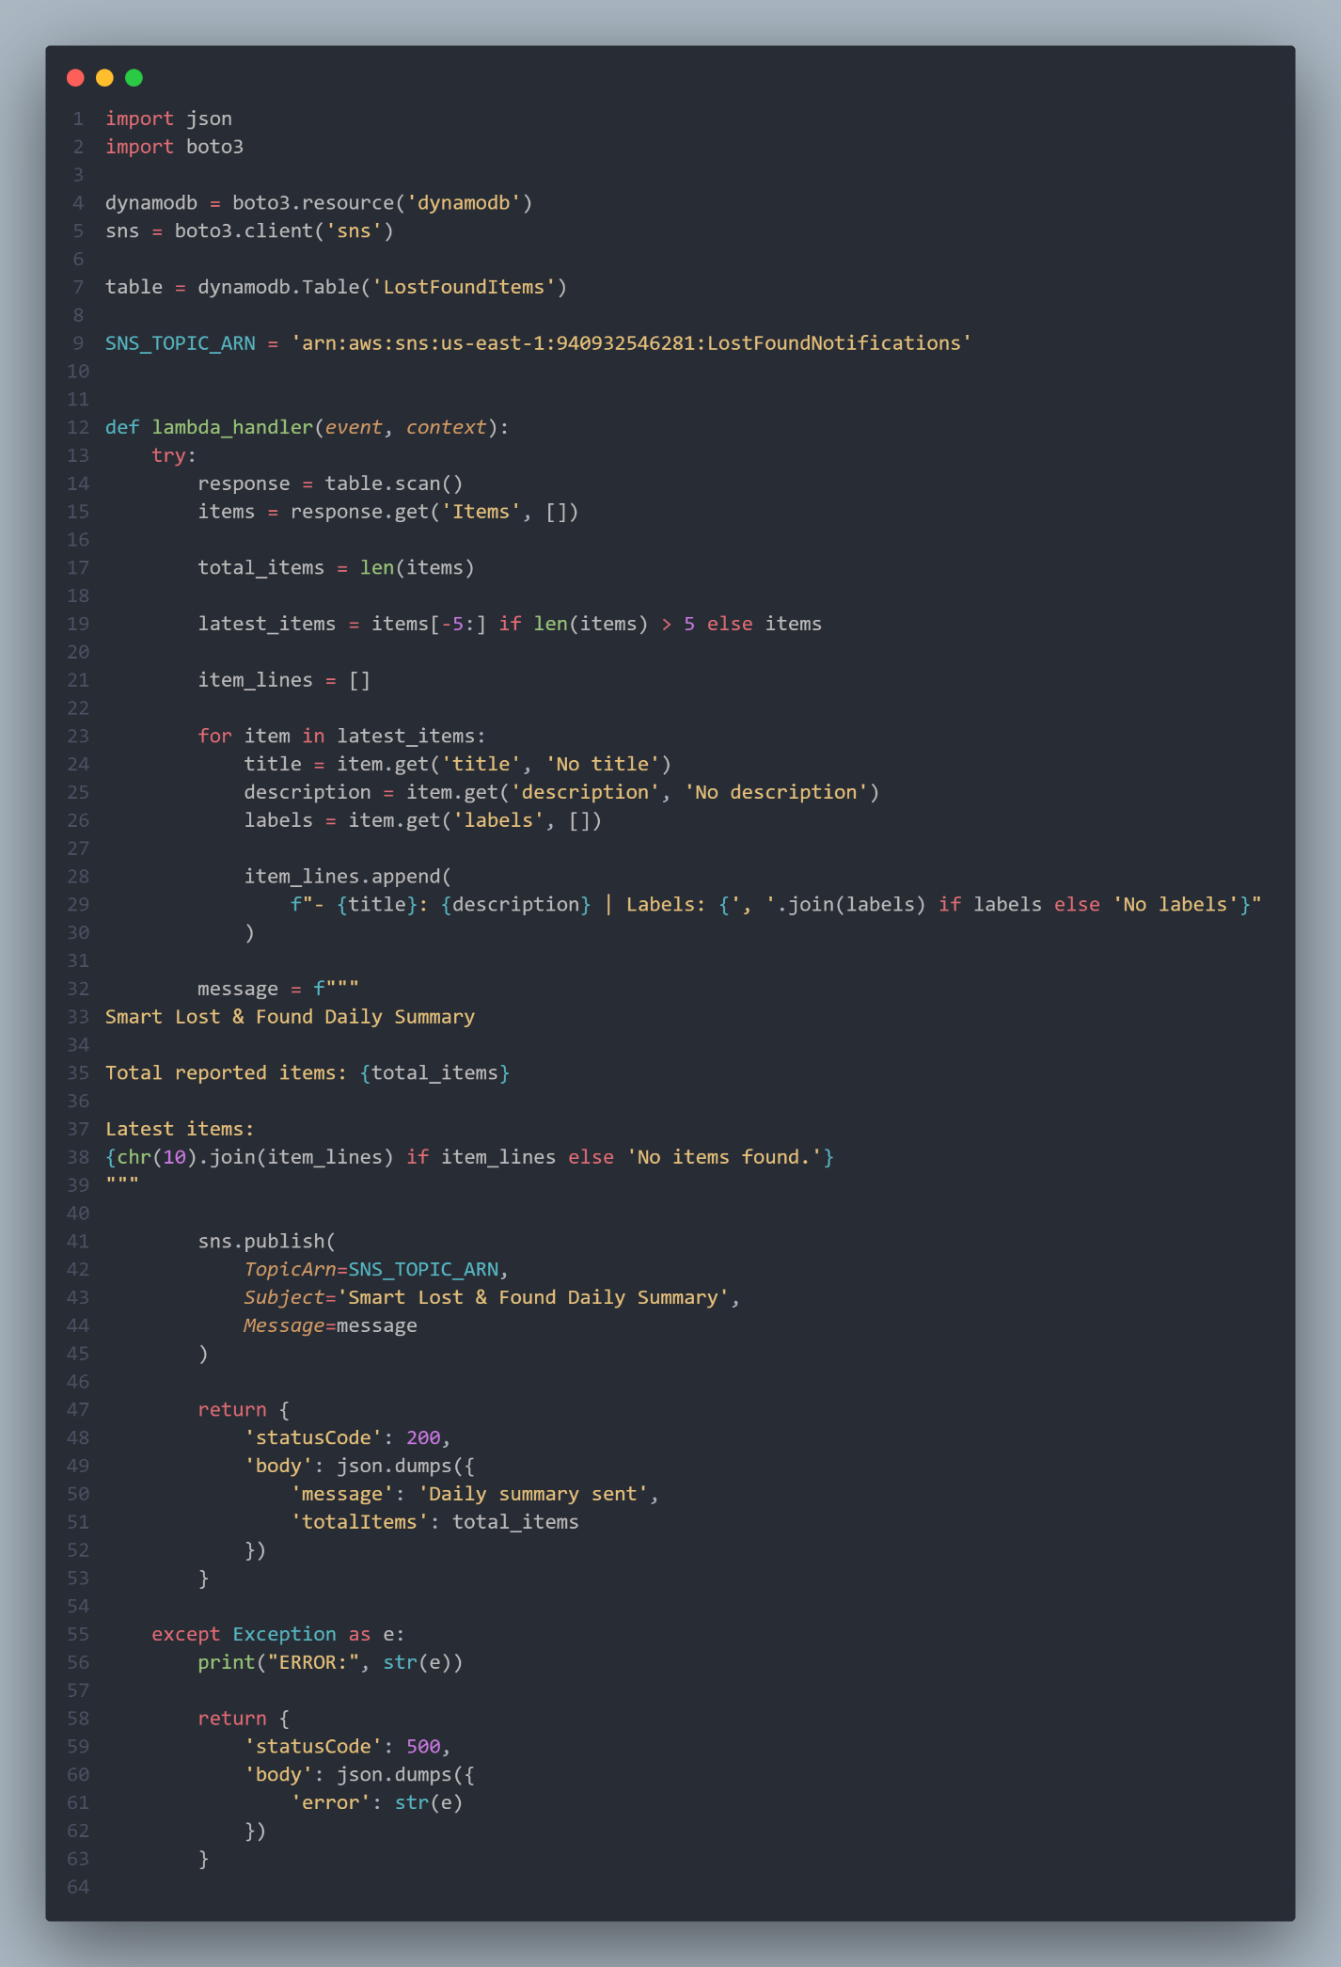

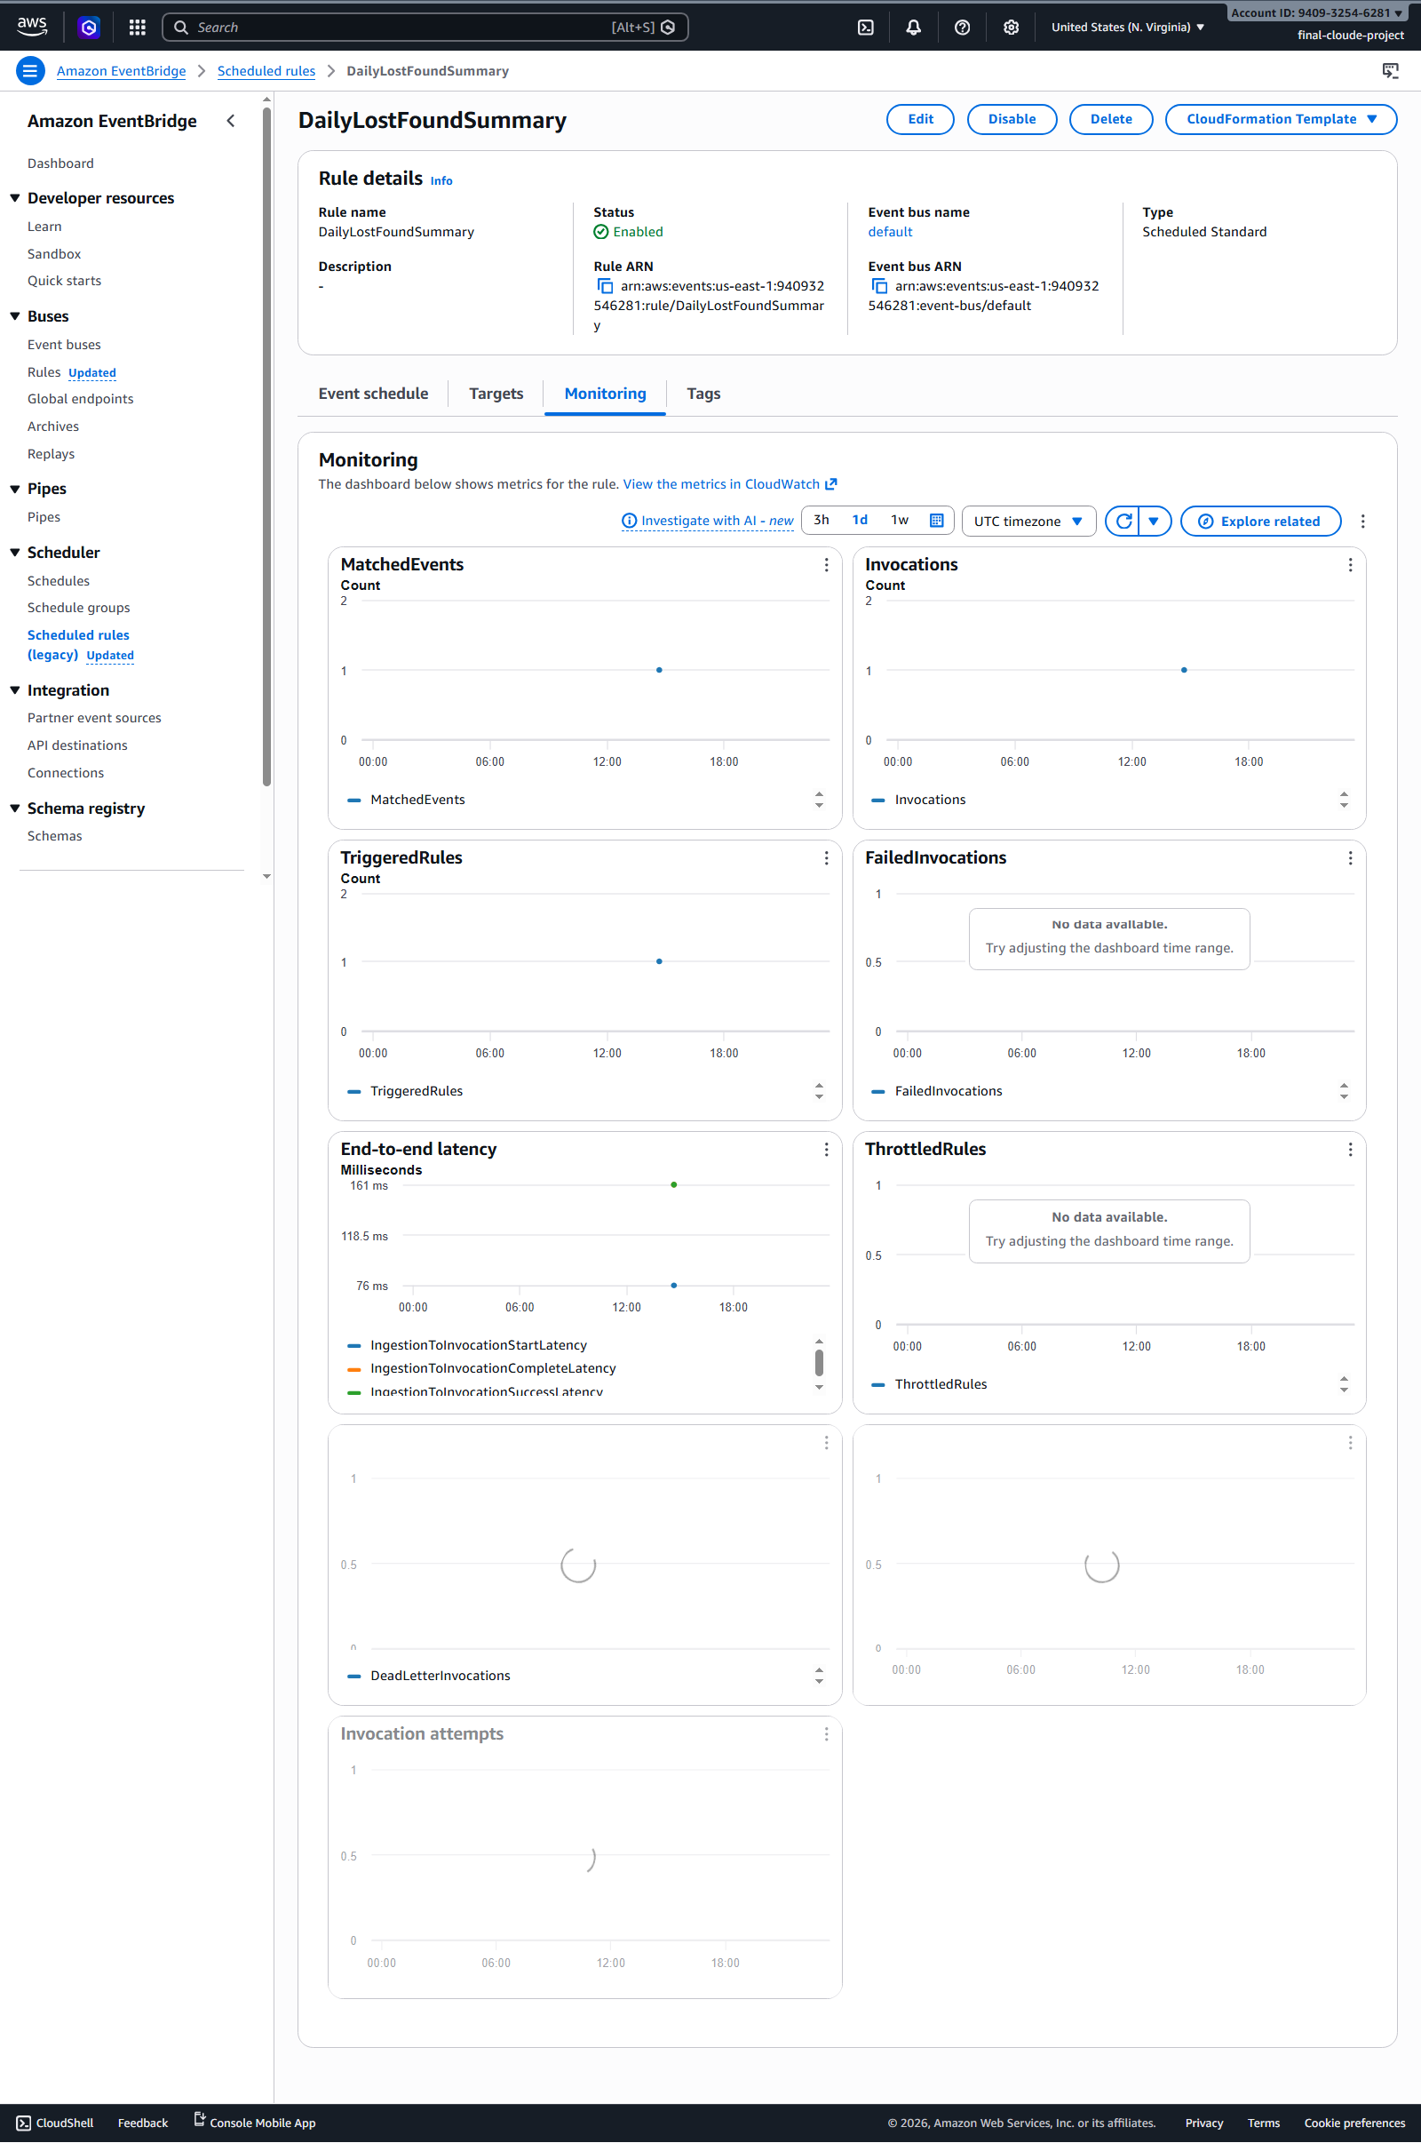

3. Advanced Data Security
The project implements advanced data security practices to protect user access, backend APIs, stored images, and administrative actions. Security is applied at multiple layers: authentication, API authorization, backend authorization, IAM permissions, and private file access.

3.1 Authentication with Amazon Cognito
Amazon Cognito is used to authenticate users before they can access the application dashboard and API operations. Users must register, confirm their email, and log in before using protected features.
After successful login, Cognito issues a JWT token that is stored on the client side and sent with API requests.
Authorization: Bearer <JWT Token>

3.2 API Protection with API Gateway JWT Authorizer
Amazon API Gateway uses a JWT Authorizer connected to the Cognito User Pool. The authorizer validates the token before allowing requests to reach the Lambda backend.
Protected routes include:
Method | Route | Protection
GET | /items | Requires valid Cognito JWT
POST | /items | Requires valid Cognito JWT
PUT | /items/claim | Requires valid Cognito JWT
PUT | /items/status | Requires valid Cognito JWT and Admin role
DELETE | /items/{itemId} | Requires valid Cognito JWT and Admin role
This prevents unauthenticated users from accessing the backend API directly.

3.3 Role-Based Access Control with Cognito Groups
The system uses Cognito Groups to separate permissions between regular users and administrators.
The project includes two groups:
User
Admin
Regular users can report and claim items. Admin users can access the Admin Queue and mark items as returned.

3.4 Backend Authorization in Lambda
Admin permissions are not enforced only in the frontend. The backend Lambda function updateItemStatus also checks the authenticated user's Cognito group before allowing an item to be marked as returned.
If a non-admin user attempts to call the admin-only endpoint, the Lambda function returns:
{
"error": "Only admins can mark items as returned"
}
This protects the system even if someone tries to call the API manually using a tool such as Postman or browser DevTools.

3.5 Private S3 Image Storage
Uploaded item images are stored in an Amazon S3 bucket. The bucket is not used as a fully public image hosting bucket. Instead, images are accessed through temporary pre-signed URLs generated by the backend.
This means the frontend can display item images without exposing the entire S3 bucket publicly.

3.6 Secure Image Delivery with Pre-Signed URLs
The getLostItems Lambda function generates temporary pre-signed URLs for item images. These URLs allow secure time-limited access to private S3 objects.
Image access workflow:
Private image stored in S3
↓
getLostItems Lambda generates pre-signed URL
↓
Frontend displays image temporarily

3.7 IAM-Based Permission Control
Each Lambda function uses IAM permissions to access the AWS services it needs. For example:
Lambda Function | Required Permissions
createLostItem | DynamoDB PutItem, S3 PutObject, Rekognition DetectLabels, SNS Publish
getLostItems | DynamoDB Scan, S3 GetObject
claimItem | DynamoDB UpdateItem
updateItemStatus | DynamoDB UpdateItem
sendDailySummary | DynamoDB Scan, SNS Publish
This follows the least-privilege security principle by limiting each function to only the actions required for its purpose.

Bonus Summary Table
Bonus Category from Requirements | AWS Service / Feature Used | Implementation in Project | Status
Advanced monitoring with CloudWatch | Amazon CloudWatch | Lambda logs, metrics, and error alarm | Implemented
Use of EventBridge or Step Functions | Amazon EventBridge | Scheduled daily summary Lambda trigger | Implemented
Advanced data security | Cognito, API Gateway JWT Authorizer, IAM, S3 pre-signed URLs | Authentication, role-based access, protected APIs, private images, least-privilege permissions | Implemented

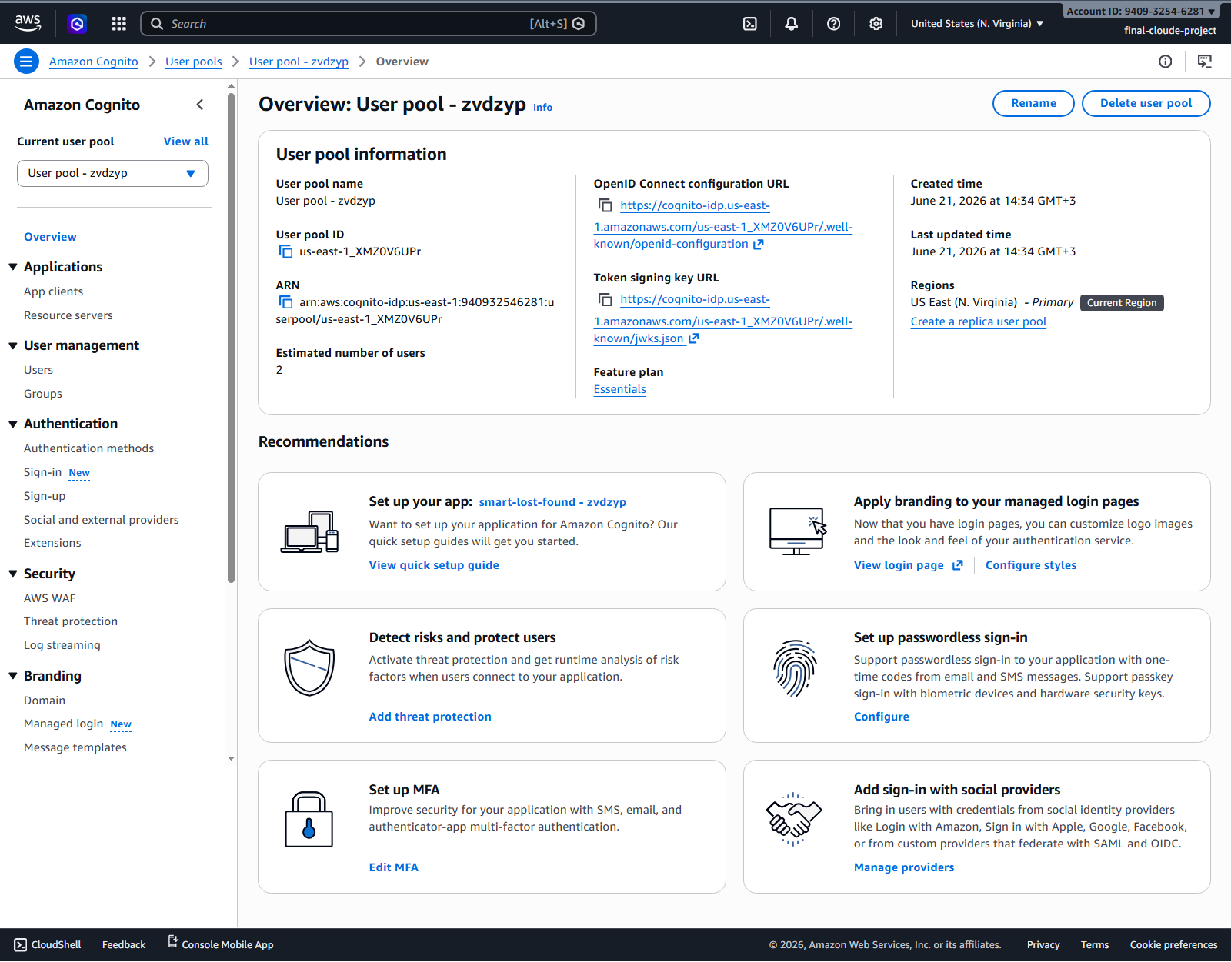
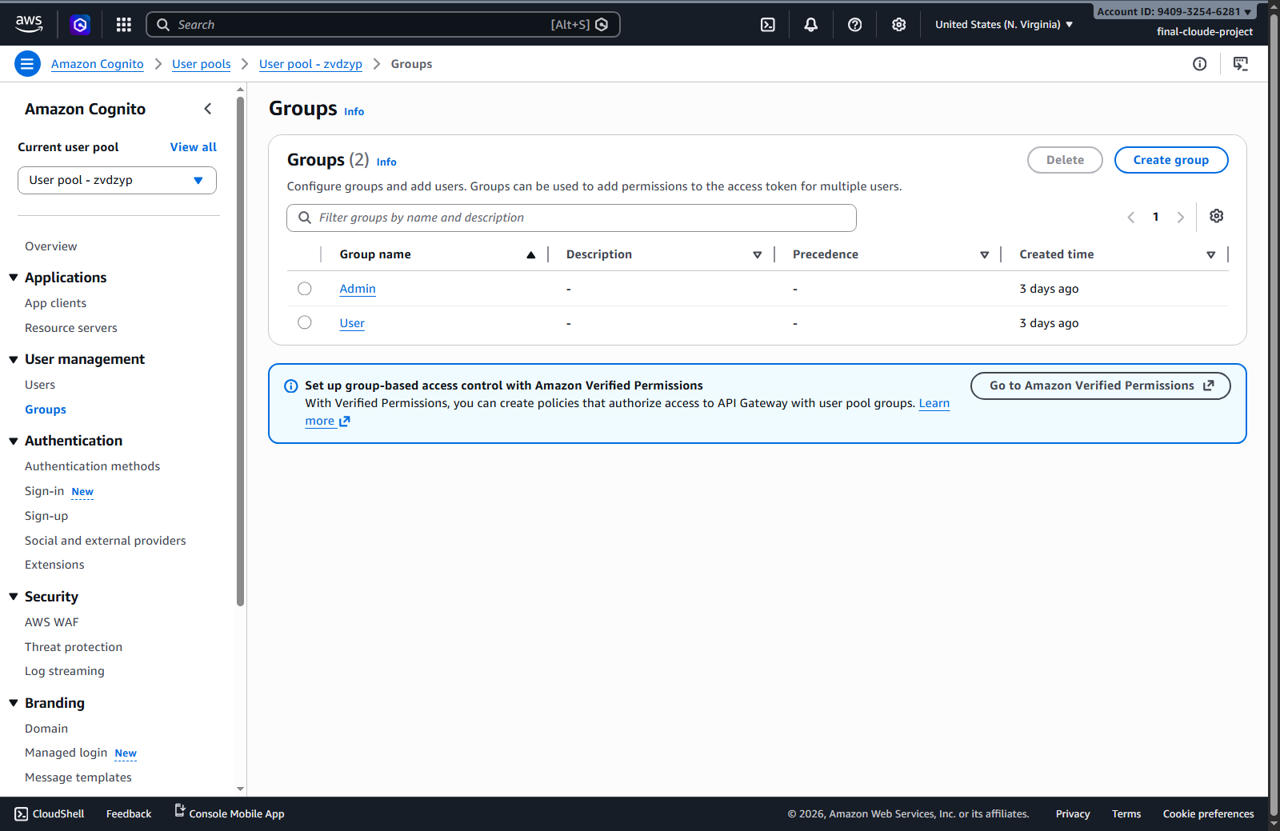
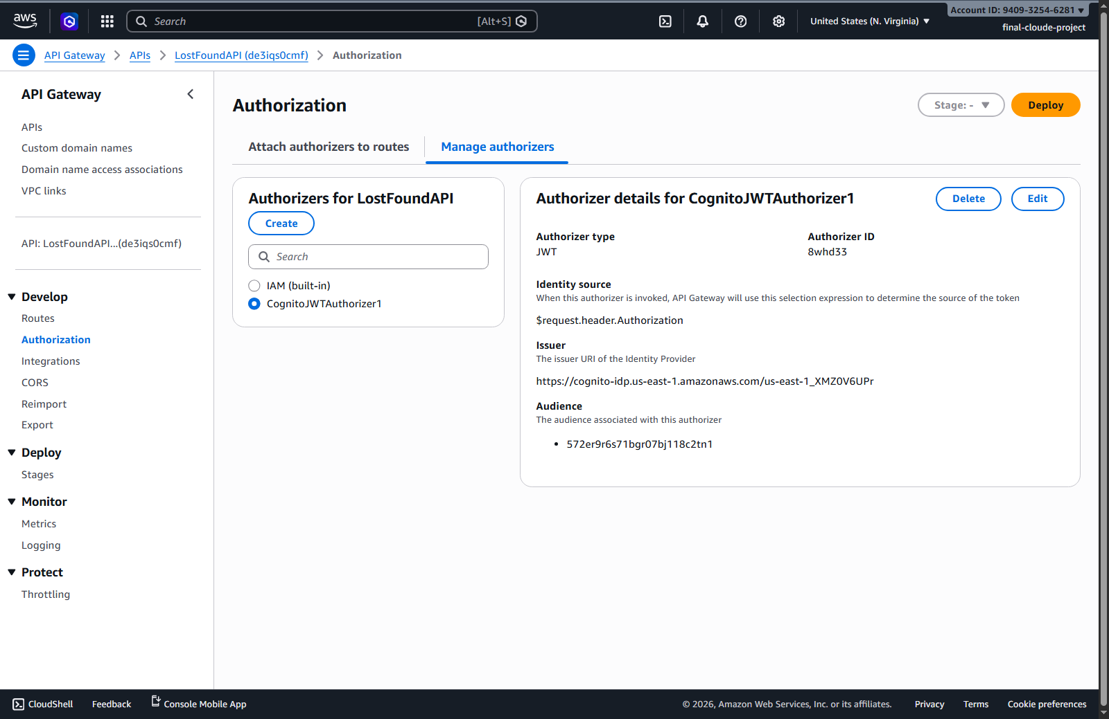

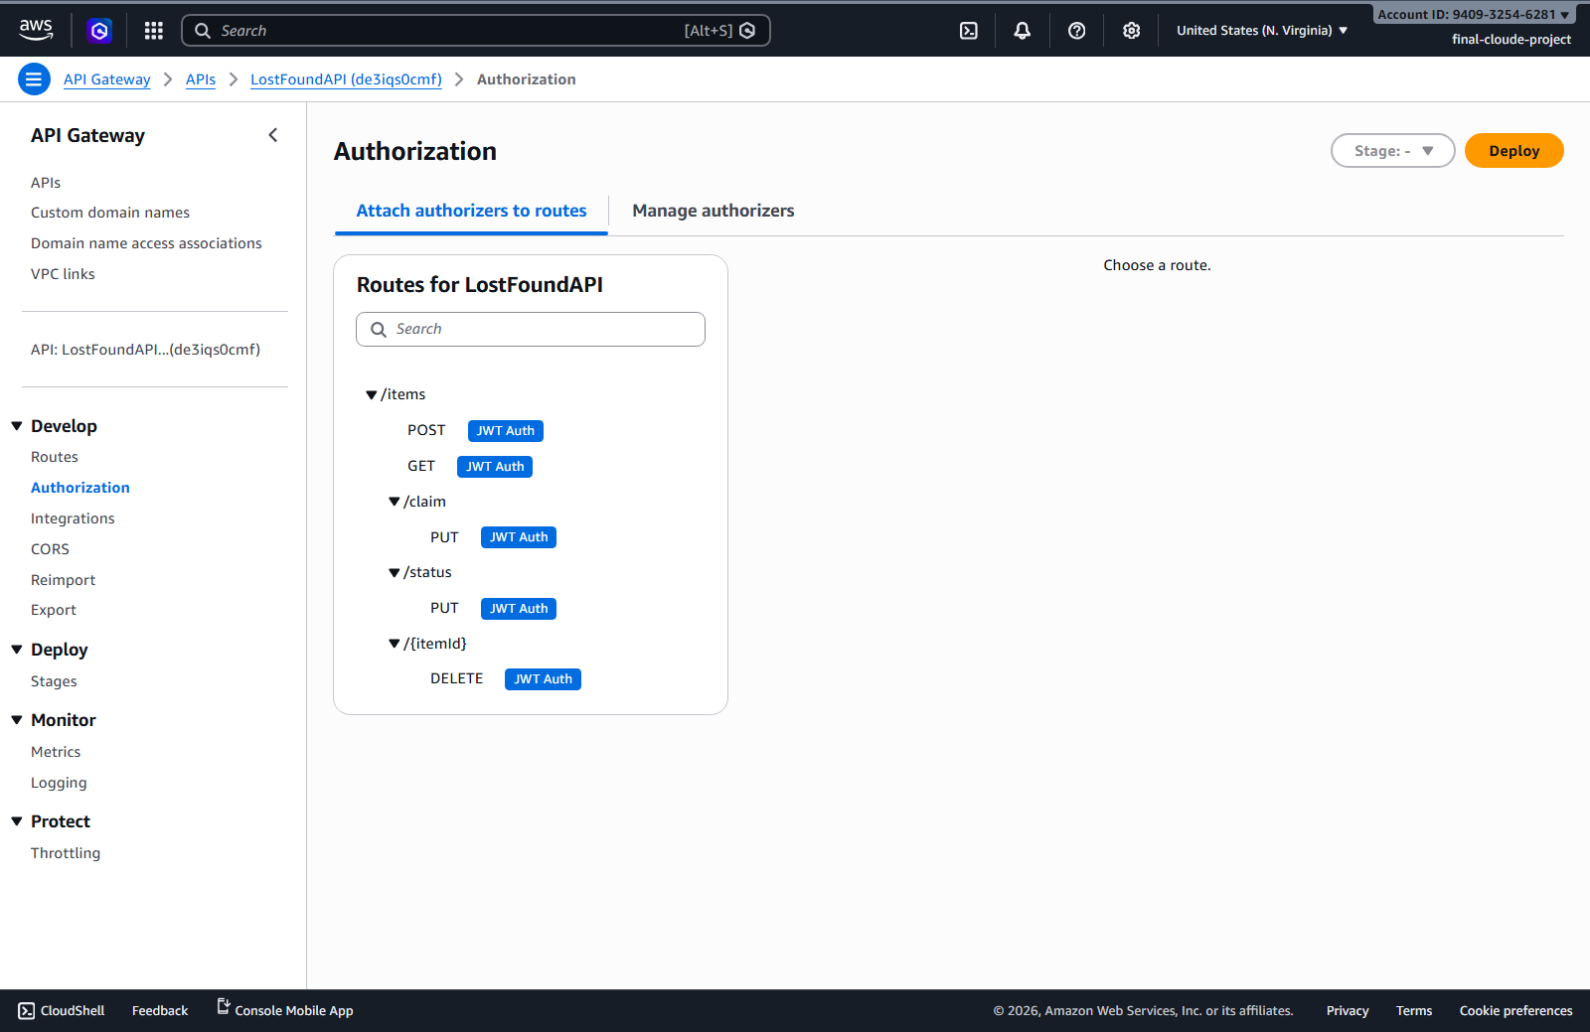
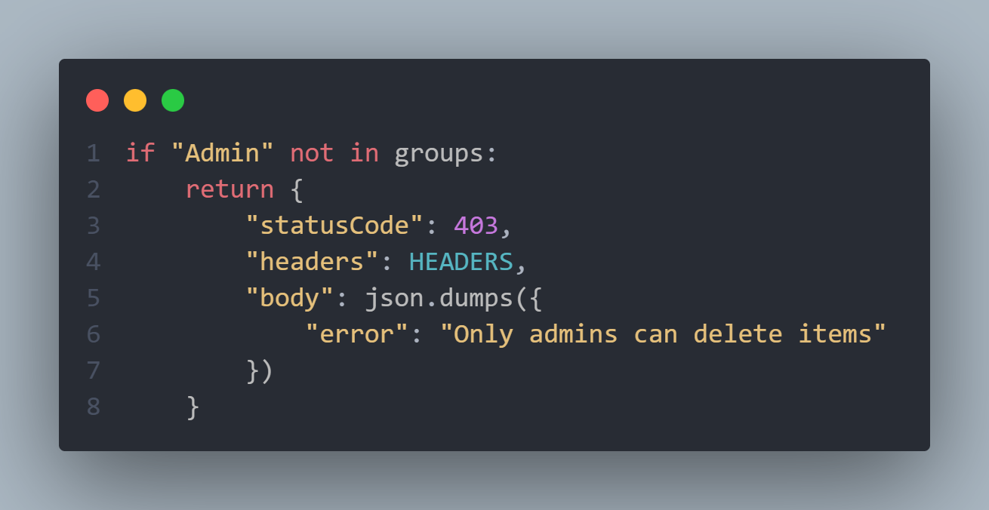

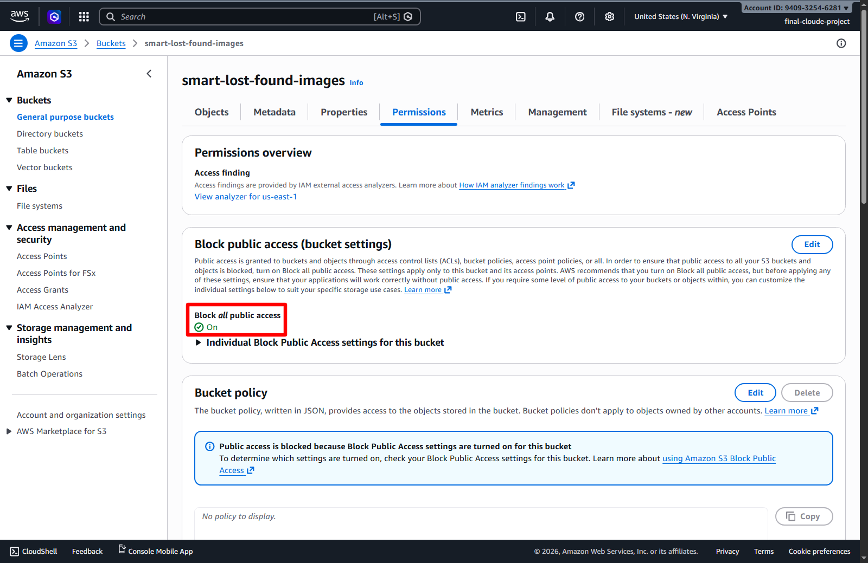

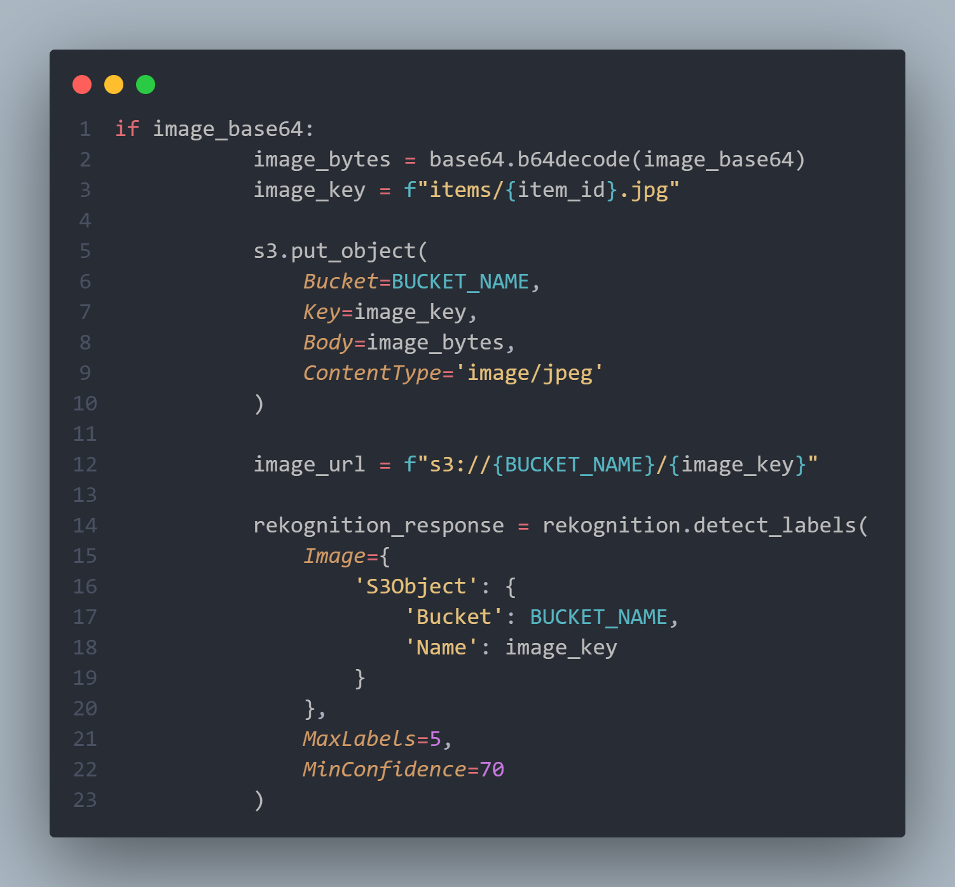

Ex. IAM Policy for Lambda createLostItem
